Name – Shreya Panda PRN – 25070122181 CSE B3
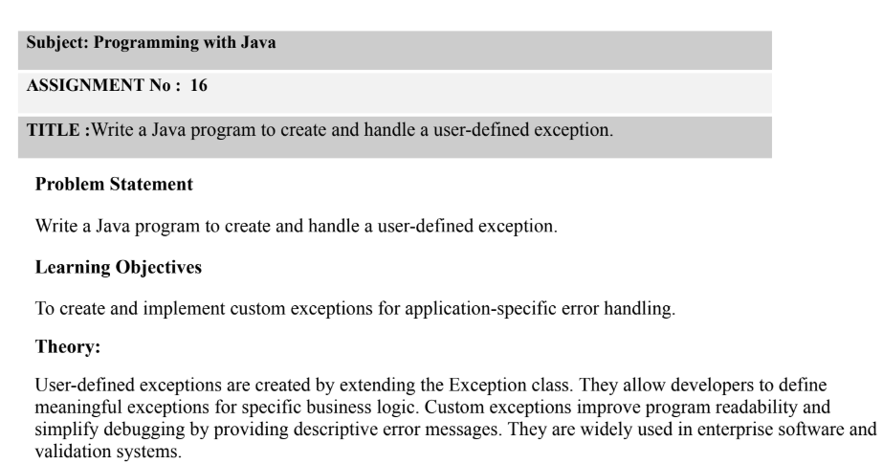
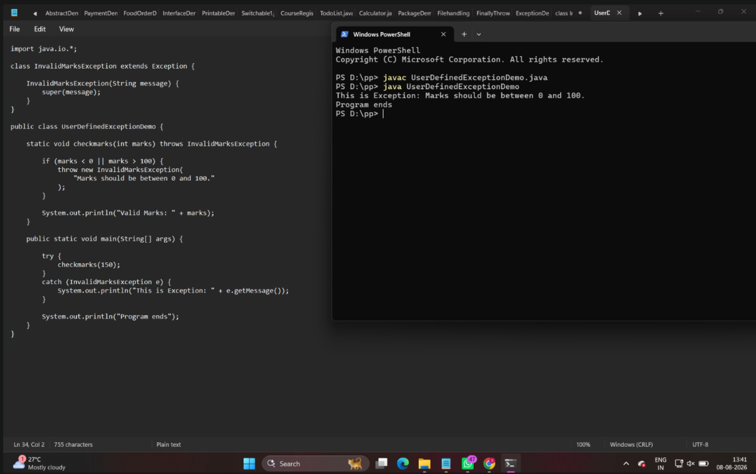
Outcome
Successfully created and handled a user-defined exception in Java by extending the Exception class. The program demonstrates how custom exceptions can be used to handle application-specific errors with meaningful error messages.
Exercise:-
- Create a Voting System that throws a custom exception if age is below 18
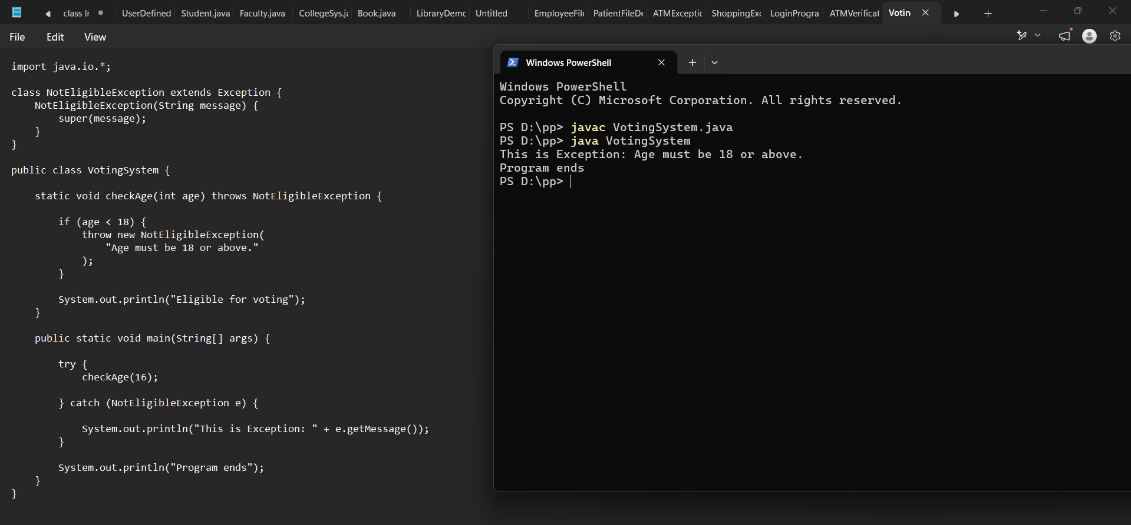
- Create a Driving License System that throws a custom exception if the user’s age is below18. If the age is valid, display that the user is eligible for a driving license
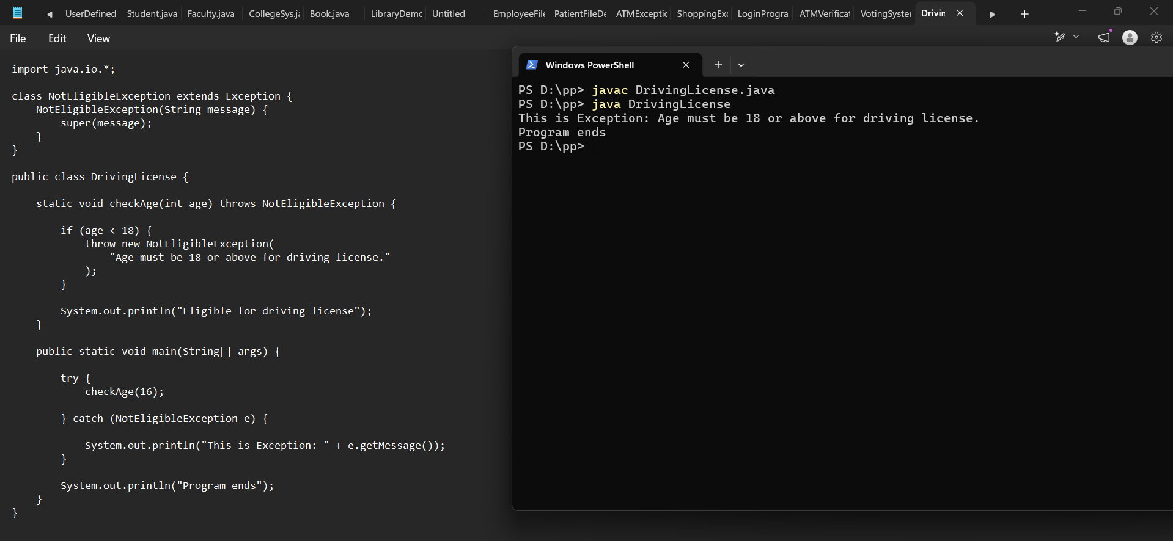

Conclusion
The experiment helped in understanding how to create and implement user-defined exceptions in Java. Custom exceptions make programs easier to understand, debug, and maintain by providing specific error messages for different application conditions.

